Article

Generation, spectroscopic and chemical characterization of an

octahedral iron (V) – nitrido species with a neutral ligand platform Gerard Sabenya, Laura Lazaro, Ilaria Gamba, Vlad Martin-Diaconescu, Erik Andris, Thomas Weyhermüller, Frank Neese, Jana Roithova, Eckhard Bill, Julio Lloret-Fillol, and Miquel Costas
J. Am. Chem. Soc., Just Accepted Manuscript • DOI: 10.1021/jacs.7b00429 • Publication Date (Web): 09 Jun 2017
Downloaded from http://pubs.acs.org on June 19, 2017

Just Accepted

“Just Accepted” manuscripts have been peer-reviewed and accepted for publication. They are posted online prior to technical editing, formatting for publication and author proofing. The American Chemical Society provides “Just Accepted” as a free service to the research community to expedite the dissemination of scientific material as soon as possible after acceptance. “Just Accepted” manuscripts appear in full in PDF format accompanied by an HTML abstract. “Just Accepted” manuscripts have been fully peer reviewed, but should not be considered the official version of record. They are accessible to all readers and citable by the Digital Object Identifier (DOI®). “Just Accepted” is an optional service offered to authors. Therefore, the “Just Accepted” Web site may not include all articles that will be published in the journal. After a manuscript is technically edited and formatted, it will be removed from the “Just Accepted” Web site and published as an ASAP article. Note that technical editing may introduce minor changes to the manuscript text and/or graphics which could affect content, and all legal disclaimers and ethical guidelines that apply to the journal pertain. ACS cannot be held responsible for errors or consequences arising from the use of information contained in these “Just Accepted” manuscripts.

.

1
2
3 Generation, spectroscopic and chemical characterization of an
4
5
6 octahedral iron (V) – nitrido species with a neutral ligand
7
8 platform
9
10 Gerard Sabenya,a Laura Lázaro,a Ilaria Gamba,a Vlad Martin-Diaconescu,a,* Erik Andris,b
11
12 Thomas Weyhermüller,c Frank Neese,c* Jana Roithova,b,* Eckhard Bill,c,* Julio Lloret-Fillol,*,d,e
13 Miquel Costas.*,a
14
15
16
17
18 a) Institut de Química Computacional i Catàlisi (IQCC) and Departament de Química, Universitat
19
20 de Girona. Campus Montilivi; E17071 Girona, Catalonia (Spain). miquel.costas@udg.edu,
21 vladmartind@gmail.com
22
23 b) Department of Organic Chemistry, Faculty of Science, Charles University in Prague, Hlavova
24 2030/8, 12843 Prague 2 (Czech Republic). jana.roithova@natur.cuni.cz
25
26 c) Max Planck Institut für Chemische Energiekonversion, Stiftstraße 34-36, 45470 Mülheim an der
27 Ruhr (Germany). eckhard.bill@cec.mpg.de, Frank.Neese@cec.mpg.de
28 d) Institute of Chemical Research of Catalonia (ICIQ), the Barcelona Institute of Science and
29
30 Technology, Avinguda Paisos Catalans 16, 43007, Tarragona (Catalonia, Spain). jlloret@iciq.es
31 e) Catalan Institution for Research and Advanced Studies (ICREA), Passeig Lluïs Companys, 23,
32
33 08010, Barcelona (Spain).
34
35
36
37
38
39
40
41
42
43
44
45
46
47
48
49
50
51
52
53
54
55
56
57
58
59
60

1
2
3 Abstract
4
5
6 Iron complex [FeIII(N3)(MePy2tacn)](PF6)2 (1), containing a neutral triazacyclononane-based
7

8 pentadentate ligand, and a terminally bound azide ligand has been prepared and spectroscopically
9
10 and structurally characterized. Structural details, magnetic susceptibility data and Mössbauer
11 spectra demonstrate that 1 has a low-spin (S = 1/2) ferric center. X-Ray diffraction analysis of 1
12
13 reveals remarkably short Fe – N (1.859 Å) and long FeN – N2 (1.246 Å) distances, while the FT-
14
15 IR spectra show an unusually low N – N stretching frequency (2019 cm-1), suggesting that the
16 FeN – N2 bond is particularly weak. Photolysis of 1 at 470 nm or 530 nm caused N2 elimination
17
18 and generation of a nitride species that on the basis of Mössbauer, magnetic susceptibility, EPR,
19 and X-ray absorption, in conjunction with DFT computational analyses, is formulated as
20

21 [FeV(N)(MePy2tacn)]2+ (2). Results indicate that 2 is a low-spin (S =1/2) iron(V) species, which
22
23 exhibits a short Fe-N distance (1.64 Å), as deduced from EXAFS analysis. Compound 2 is only
24 stable at cryogenic (liquid N2) temperatures, and frozen solutions as well as solid samples
25
26 decompose rapidly upon warming, producing N2. However, the high-valent compound could be
27
28 generated in the gas phase and its reactivity against olefins, sulphides and substrates with weak
29 C-H bonds studied. Compound 2 proved to be a powerful two-electron oxidant that can add the
30
31 nitride ligand to olefin and sulphide sites, as well as oxidize cyclohexadiene substrates to benzene
32 in a formal H2 transfer process. In summary compound 2 constitutes the first case of an octahedral
33

34 FeV(N) species prepared within a neutral ligand framework, and adds to the few examples of FeV
35
36 species that could be spectroscopically and chemically characterized.
37
38
39
40
41
42
43
44
45
46
47
48
49
50
51
52
53
54
55
56
57
58
59
60

1
2
3 Introduction
4
5
6 High-valent iron compounds are highly reactive species that are involved in a number of reactions
7
8 of interest in biology, chemical synthesis and technology.1-7 For instance high-valent iron-oxo
9
10 species are key intermediates in challenging oxidation reactions such as C-H hydroxylation8-10
11 and water oxidation,11-13 while high-valent nitride and related species have been considered as
12
13 possible intermediates in iron-mediated dinitrogen reduction to ammonia. One of the mechanisms
14
15 proposed for the latter process is the release of ammonia and the generation of a high valent
16 FeIV≡N intermediate, which in biology is suggested to take place at a single iron site on the FeMo
17
18 cofactor of nitrogenase.14
19 The nitride ligand is regarded as particularly suitable for stabilizing such high oxidation
20
21 states because of its negative charge, and its powerful σ and π donor abilities. Nevertheless,
22
23 preparation and characterization of octahedral high-valent iron species with terminal nitride
24 ligands in non porphyrinic environments remains a challenge for synthetic inorganic chemistry,
25
26 although their reactivity is of high interest.4,15-19 In contrast, quasi-tetrahedral iron(IV) – nitride
27
28 species can be made relatively stable by using bulky ligands and their reactivity was explored in
29 some detail.20-26 Nitride transfer to styrene,26 isocianides24 and triarylphosphines27 has been
30
31 documented. In addition, reaction with cyclohexadienes has been shown to proceed via
32 cycloaddition and hydrogen-abstraction.25 Peters and Smith have independently shown that
33
34 bimolecular reactions between iron(IV) – nitride complexes lead to FeI-NN- FeI dimeric
35
36 species.20,21 Some of these complexes also reacted with water protons and electrons to afford
37 quantitative amounts of ammonia.28
38
39
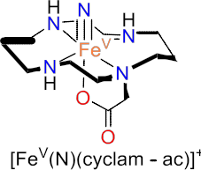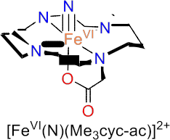40
41
42
43
44
45
46
47
48
49
50
51
52
53
54
55
56 Scheme 1. Representative examples of non-heme iron(V) nitride complexes within the cyclam
57 (B),29(A)30 and tetrapodal pentadentate (NN4, D)31 tetragonal frameworks as well as pseudo-
58 tetrahedral iron(V) nitride (E)32 and iron(VI) nitride species (C)33 reported in the literature.
59
60

1
2
3 Nitridoiron(V) porphyrins were first described by Nakamoto et al, produced by laser
4
5 irradiation of thin films of the corresponding azido complexes at -30 K, but could only be
6 characterized by resonance Raman.19 Pioneering examples of iron(V) nitrido species in octahedral
7
8 environments were described by Wieghardt et al, via photolysis of the corresponding ferric –
9
10 azide precursors in frozen matrices.29,30 The same authors also described preparation of an
11 iron(VI) nitrido species by photolysis of the corresponding iron(IV) – azide complex.33 The use
12
13 of the frozen matrix proved crucial for the successful preparation of these species. However,
14
15 attempts to prepare analogous complexes with anionic triazacyclononane based pentadentate
16 ligands resulted instead in the generation of ferrous complexes via homolytic cleavage of the Fe
17
18 – Nazide bond.34 Most remarkably, Smith and Meyer have recently described the preparation and
19 structural characterization of an iron(V) – nitride species with a sterically encumbered tris –
20

21 carbene ligand that enforces a distorted tetrahedral geometry.32,35
22
23 With the single exception of the latter, iron(V) – nitride species can only be prepared in
24 frozen solutions at cryogenic temperatures, and their reactivity remains poorly explored. The
25
26 iron(V) – nitride species described by Smith and Meyer has been shown to react with water to
27
28 produce ammonia,32 while N – N coupling has been documented in the thermal decomposition of
29 [FeV(N)(cyclam – ac)]+ and trans – [FeV(N3)(N)(cyclam)]+.36 Furthermore, formation of trans –
30
31 [FeV(N3)(N)(cyclam)]+ by N2 extrusion from the ferric – azide precursor, and its reaction with
32 triphenylphosphine has been monitored by real time FT-IR.37 Gas phase reactivity has also proven
33

34 to be a convenient tool to generate and study the chemistry of highly reactive high valent iron-
35
36 nitride species,31,38 although ligand degradation appears to be a competing or even a dominating
37 path in some of the previous studies.38
38
39 Overall, these precedents evidence that examples of high-valent iron – nitride species
40
41 remain scarce. Their high reactivity makes them very interesting but at the same time hampers
42 their preparation and the study of their reactivity. With these considerations in mind, we targeted
43
44 the synthesis, and characterization of a novel octahedral iron(V) – nitride species, and the
45 investigation of its reactivity. Towards this end, this work describes the photolysis of the iron –
46

47 azide complex [FeIII(N3)(MePy2tacn)](PF6)2 (1, MePy2tacn = N – methyl – N, N – bis(2– picolyl)
48
49 – 1, 4, 7 – triazacyclononane) to generate the corresponding high-valent iron(V) species
50 [FeV(N)(MePy2tacn)]2+ (2), which has been spectroscopically characterized by a combination of
51
52 methods (Mössbauer, magnetic susceptibility, EPR, and X – ray absorption spectroscopy) as well
53
54 as DFT computational analysis. While previously described octahedral iron(V)-nitride complexes
55 have aliphatic polyamine ligands (scheme 1), 2 bears an oxidatively more robust polypyridyl
56
57 ligand scaffold. This element endorses 2 with a comparatively enhanced stability which permits
58 its generation in nearly quantitative yields. Complex 2 is only stable at very low temperatures in
59
60 frozen solution but its reactivity against external substrates can be studied in the gas phase.

1
2
3 Therefore, 2 constitutes a very rare example of an iron(V) species that could be spectroscopically
4
5 characterized and whose reactivity could be explored.
6
7
8 Results and Discussion
9
10
11
12 Synthesis and characterization of [FeIII(N3)(MePy2tacn)](PF6)2 (1).
13 Ferric species [FeIII(N3)(MePy2tacn)](PF6)2 (1), was prepared by reacting equimolar
14
15 amounts of iron(III) triflate and the MePy2tacn ligand in THF under anaerobic conditions (Figure
16
17 1, left) . The resulting reddish solution was evaporated under vacuum, and the resulting solid was
18 dried and solved in water followed by addition of excess NaN3. The solution was stirred for ~2
19
20 hours and a saturated solution of NaPF6 or NH4PF6 was added with continuous stirring for an
21 additional ~2 hours. A purplish solid precipitate was formed, filtered and recrystallized in acetone
22
23 using diethyl ether diffusion. The final product is a 1H – NMR silent ferric – azide species
24
25 [FeIII(N3)(MePy2tacn)](PF6)2 (1) as characterised by Mössbauer, UV – vis, IR, Raman, EPR,
26 magnetic susceptibility and mass spectrometry.
27
28
29
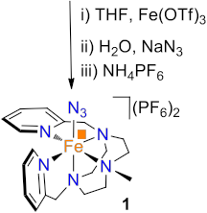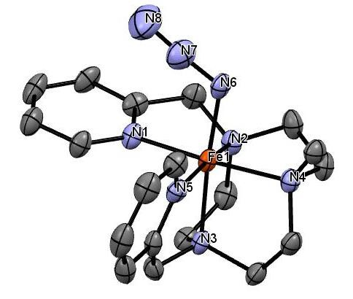30
31
32
33
34
35
36
37
38
39
40
41
42
43 Figure 1. (Left) Schematic diagram for the preparation of complex 1. (Right) Solid-state
44 structure of 1 with ellipsoids set at 50% probability. Protons and hexafluorophosphate (PF6)-
45 anions were omitted for clarity. Selected bond distances and angles: Fe(1) – N(6), 1.859(5) Å;
46 N(6) – N(7), 1.246(7) Å; Fe(1) – N(6)-N(7), 122.2(4)º.
47
48
49 The solid-state structure of 1 could be determined by single crystal X – ray diffraction
50 analysis. Figure 1 (right) shows the ORTEP diagram of the cationic part of the complex with
51
52 selected bond lengths and angles. The complex contains an iron center in a distorted octahedral
53
54 coordination geometry having five coordination sites occupied by the N atoms of the neutral
55 ligand framework and one azide anion to complete the coordination environment. One of the
56
57 coordinating pyridines is coplanar to the Fe – N3 axis, while the second is perpendicular to this
58
59 axis. Furthermore, the azide and the pyridine ligands are trans to N atoms of the tacn moiety.
60 Interestingly, in 1 the Fe – N(6) bond is remarkably shorter at 1.859 Å and the FeN(6) – N(7)

bond remarkably longer at 1.246 Å, than in any of the previously described ferric – azide

1
2
3 complexes (Table 1). Literature precedents show that low-spin (S = 1/2) ferric complexes exhibit
4
5 shorter Fe – N and larger FeN – N2 distances than high-spin ferric complexes, but the values
6 measured for 1 presumably also reflect a higher electrophilicity of the ferric center due to the
7
8 neutral character of the MePy2tacn ligand. Instead, previous examples of ferric – azide complexes
9
10 (Table 1) contain anionic ligands that compensate the positive charge of the ferric center.
11 The zero-field Mössbauer spectrum of 1 recorded at 80 K shows a single doublet with
12
13 low isomer shift and large quadrupole splitting, δ = 0.21 mm·s-1, ΔEQ = 2.13 mm·s-1 (Figure 2-
14
15 top). These values are characteristic of low-spin iron(III) centers which is in agreement with the
16 effective magnetic moments of 1.5 - 1.8 μB measured between 10 and 300 K (Figure S2).
17
18 Consistently, the EPR spectrum of 1 in frozen acetone solution at 10 K is also characteristic of a
19
20 low-spin iron(III) (S = 1/2), showing rhombic symmetry with simulated g values g1 = 2.58, g2 =
21 2.26 and g3 = 1.83 (Figure 2-bottom).
22
23
24
25
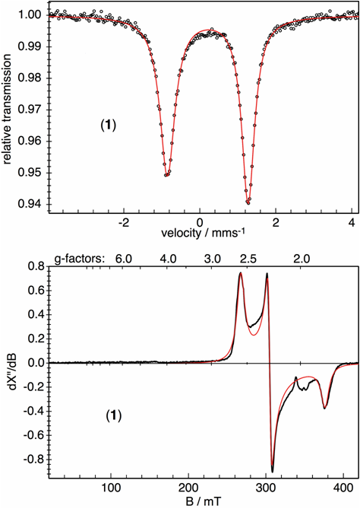26
27
28
29
30
31
32
33
34
35
36
37
38
39
40
41
42
43
44
45
46
47
48
49
50
51
52
53
54
55 Figure 2. (top) Zero-field Mössbauer spectrum of solid 1 at 80 K, and (bottom) X-band EPR
56 spectra of 2 in frozen acetone solution at 10 K (frequency 9.6437 GHz, power 0.2 mW,
57 modulation 0.75 mT / 100 kHz). The EPR derivative amplitudes are given in arbitrary units. The
58 red lines in both spectra are simulations. The asymmetry of the Mössbauer spectrum results from
59 a difference in line widths, presumably due to intermediate spin relaxation of the half-integer spin
60 system, or/and due to slight heterogeneity of iron sites in the powder sample.

1
2
3 The resonance Raman spectrum of complex 1 exhibits a weak signal at 2026 cm-1,
4
5 assigned to the asymmetric stretching of the coordinated azide, whereas the FT – IR spectra shows
6 a single peak at 2019 cm-1, assigned to the azide stretching vibration (Figure S1).39 Moreover,
7
8 when 1 was prepared using 15N terminally labelled sodium azide, its IR spectrum exhibited two
9
10 features at 2021 and 1998 cm-1 equal in intensity, assigned to the N – N stretching mode. The ν(N
11 – N) downshift from 2021 cm-1 to 1998 cm-1 (Δν = 23 cm-1) is lower than the expected 33 cm-1
12
13 shift for a diatomic N – N oscillator. This suggests that the observed features are not only
14
15 reflecting the stretching from the N – N bond but possibly a contribution of the rest of the azide
16 moiety or of the iron centre to the observed vibrations.
17
18 Of particular interest is also the lower frequency of the N – N stretching frequency of 1
19
20 when compared with the other ferric – azide complexes described in Table 1. The energy of
21 stretching vibrations observed by FT-IR spectroscopy nicely agree with the metrical parameters
22
23 of the Fe – Nazide unit determined from the crystallographic structure of 1, and conversely indicate
24
25 that the Fe – N bond is particularly strong while the FeN-N bond is unusually weak. The structural
26 and spectroscopic data therefore suggest that the FeN-N bond could be readily activated towards
27
28 breakage and release of N2.
29
30
31 Table 1. Azide stretching frequencies and Mössbauer parameters for the studied (top) and
32 bibliography compounds (below).
33

34
35 Compound
36
ν

(cm-1)
Spin
State
Fe – N
distance
(Å)
FeN – N
distance
(Å)
δ

(mm·s-1)
ΔEQ

(mm·s−1)

37 NaN3 2120 --- --- --- --- ---
38
39 [FeIII(N3)(MePy2tacn)](PF6)2 (1) 2019 S = 1/2 1.859 1.246 0.21 2.13
40 2021

41 [FeIII(15NN2)(MePy2tacn)](PF6)2
42

1998
ND ND ND ND ND

43 b[FeIII(N3)(cyclam – ac)](PF6) 2051 S = 1/2 1.931 1.209 0.27 2.53

44
45 ccis - [FeIII(N3)2(cyclam)](ClO4)
46
2078

2047

S = 5/2
1.976

1.970
1.194

1.210

0.46 0.29

47 ctrans - [FeIII(N3)2(cyclam)](ClO4) 2044 S = 1/2 1.937 1.180 0.29 2.26
48 d[FeIII(N3)(Ac2tacnCH2C6H4OMe)] 2064 S = 5/2 --- --- 0.56 0.47
49 d[FeIII(N3)(Ac2tacniPr)] 2066 S = 5/2 1.981 --- 0.46 0.82
50
51 d[FeIII(N3)(Ac2tacnCH2C6H5)] 2066 S = 5/2 1.975 --- 0.46 0.61
52 ctrans - [FeII(N3)2(cyclam)](ClO4) --- S = 0 --- --- 0.55 0.72
53 ccis - [FeII(N3)2(cyclam)](ClO4) --- S = 2 --- --- 1.11 2.84
54
55 ND: Not determined. a Component from the mixture that was attributed to FeIII(N3). bref 29. cref 30. d ref 34.
56
57
58
59
60

1
2
3 Complex 1 was also analysed by mass spectrometry (Figure S4). The spectrum shows a
4
5 major peak at m/z = 211.58 with an isotopic pattern indicative of an [FeIII(N3)(MePy2tacn)]2+ ion.
6 Interestingly, the spectra showed two additional peaks at m/z = 190.58 and 197.58 that can be
7
8 assigned to [FeII(MePy2tacn)]2+ and [FeV(N)(MePy2tacn)]2+ ions, respectively. Tandem mass
9
10 spectrometry/mass spectrometry (MS/MS) analysis shows that they both proceed from
11 fragmentation of the m/z = 211.58 ion, indicating they originate from the cleavage of the Fe – N
12
13 and the N – N bonds of the azide complex, respectively. High resolution mass spectrometry of
14
15 15N labelled complex [FeIII(15N3)(MePy2tacn)](PF6)2 (1 – 15N) (Figure S5) confirmed the
16 assignment of the ions observed in 1. As the azide anion is labelled in one of the two terminal
17
18 positions, both the [FeV(14N)(MePy2tacn)]2+ and [FeV(15N)(MePy2tacn)]2+ were observed in a 1:1
19 ratio, where each of these ions (m/z = 197.58 and 198.08), are formed from N – N cleavage on
20

21 the [FeIII(N2=15N)(MePy2tacn)]2+ and [FeIII(15N=N2)(MePy2tacn)]2+ respectively. These
22
23 observations, again, evidence the possibility to cleave the N – N bond to gain access to high –
24 valent iron species.
25
26
27
28 Photolysis of [FeIII(N3)(MePy2tacn)](PF6)2 (1).
29
30 Photolysis in solution. When acetonitrile solutions of 1 were photolysed at 233 K with
31
32 blue or green LED lamps (470 or 530 nm, respectively) for a few minutes (15 – 20 min), formation
33 of [FeII(CH3CN)(MePy2tacn)]2+ (3) occurs, as revealed by UV-Vis spectroscopy.40 Monitoring
34
35 the reactions by UV-Vis revealed that the process occurs with isosbestic points, thus reflecting a
36 clean transformation presumably entailing formation of azide radicals via homolytic cleavage of
37
38 the Fe-N bond without significant accumulation of other species (reduction of 1 with 470 nm
39
40 irradiation is shown in Figure S6). Such behaviour has previously been reported for analogous
41 iron(III) complexes with cyclam ligands29,30 and led us to further explore the reactivity in solid
42
43 samples and frozen solutions at cryogenic temperatures to investigate the formation of possible
44
45 high-valent iron intermediates
46
47 Photolysis of solid powder samples. Solid powder samples of 1 were finely dispersed in
48 an open liquid nitrogen bath and photolysed under stirring at 77 K for ~5 h. Upon irradiation with
49
50 470 nm light, zero-field Mössbauer reveals consumption of the initial iron(III) – azide complex
51
52 1, and generation of two new species attributable to 26 % of low-spin iron(II) (δ = 0.38 mm·s-1,
53
54 ΔEQ = 0.67 mm·s-1) and 74 % of a new component (2). This latter subspectrum is broad and
55 asymmetric, as expected for half-integer spin with intermediate spin relaxation. An approximate
56
57 fit with an asymmetric quadrupole doublet revealed a remarkably low isomer shift (δ) of
58
59 approximately -0.01 mm·s-1 and moderately large quadrupole splitting (ΔEQ) of ca. 1.02 mm·s-1
60 consistent with the formation of a high-valent iron center (Figure S8-A). Magnetic susceptibility experiments of the ferric starting complex 1 after photolysis (see Figure S9) also show a sample

1
2
3 composition of 25 % of iron(II) with S = 0, and 75 % of complex 2 with S = ½, having an effective
4
5 magnetic moment that varied from ca. 0.9 µB at 2 K to ca. 1.4 µB at temperatures above 10 K.
6 Irradiation with 530 nm light also yielded quantitative conversion of the ferric starting material,
7
8 with only ca. 5 % of initial iron(III) left over in the Mössbauer spectrum (and 14 % of an initial
9
10 ferrous impurity that did not change during irradiation; Figure S8-B). However, only 4% of the
11 low-spin iron(II) photo-product was detected (δ = 0.39 mm·s-1, ΔEQ = 0.70 mm·s-1, previously
12
13 25%), and 78 % of the high-valent iron (2) subspectrum (δ = 0.0 mm·s-1, ΔEQ = 0.86 mm·s-1). In
14
15 summary, this reveals 95 % conversion of the ferric 1 azide compound into the high-valent
16 compound 2 using 530 nm light, in contrast to 75% achieved by photolysis at 470 nm. Therefore
17
18 generation of 2 in frozen solution samples was further investigated using irradiation with 530 nm
19
20 light.
21
22
23 Photolysis of frozen solution samples with 530 nm light. Additional preparations with 530
24
25 nm light using 2 mM frozen (~77 K) acetone solution samples of 1 were investigated. After ~5
26 hours irradiation the solution changed color from purple to orange. Follow up Mössbauer analysis
27
28 (Figure 3, top panel) revealed virtually complete conversion of 1 into 2 (δ = -0.01 mm·s-1, ΔEQ =
29
30 1.09 mm·s-1). By comparison with the iron(V) complexes [FeV(N)(N3)(cyclam)]+ and
31 [FeV(N)(cyclam-ac)]+ (δ = -0.04 and -0.01 mm·s-1, ΔEQ = 1.90 and 1.58 mm·s-1,
32
33 respectively),29,30,36 the Mössbauer spectrum of the photoproduct (2) can be assigned, in particular
34
35 due to its low isomer shift, to a high-valent nitrido iron(V) complex with spin S = 1/2. This
36 conclusion could be supported by an EPR analysis of 1 photolysed in frozen solution inside a
37
38 sealed EPR tube under vacuum (Figure 3, lower panel). The EPR spectra recorded before and
39
40 after irradiation show quantitative consumption of the starting material (1) and formation of a new
41 EPR signal at remarkably low g ≈ 1.27. That derivative signal can be assigned to the g⊥ resonances
42
43 of a slightly rhombic spectrum for which a simulation yielded g-values of 1.59, 1,33, and 0.9
44
45 (inset of Figure 3 lower panel, red line). Numerical double integration of that spectrum, which we
46 assign to 2, and comparison with the starting material, reveals ca. 50% recovery of the spin
47
48 concentration after photolysis (after division with the appropriate Aasa-Vanngard41 factors of 2.24
49 for the spectrum of 1 and 1.27 for the spectrum of 2 to account for different g values, 20-30%
50
51 error possible). The unusually low g values of 2 which deviate significantly from the typical g
52
53 splitting around g=2 as encountered for low-spin ferric compounds like 1, render 2 experimentally
54 a nitrido iron(V) complex with S = ½ and substantially unquenched orbital moment, apparently
55
56 due to orbital degeneracy in the corresponding low-spin 3d(t2g)3 configuration. To the best of our
57
58 knowledge, EPR data from iron(V) – nitride compounds are reported only for the pseudo
59 tetrahedral complex [FeV(N)(tBuIm3BPh)]+ (S = 1/2, g┴ = 1.971, g// = 2.299),32 and for the
60
octahedral complexes [FeV(N)(cyclam-ac)]+ (g1 = 1.629 and g2 = 1.746, g3 = 1.036,) and

1
2
3 [FeV(N)(N3)(cyclam)]+ (g1 = 1.626, g2 = 1.748, g3 = 0.985).42 Apparently the ligand-field situation
4
5 of 2 resembles that of the quasi octahedral, cyclam-based nitrido iron(V) species and its observed
6
7 EPR resonances fall within the same range of g⊥ values.
8
9
10
11
12
13
14
15
16
17
18
19
20
21
22
23
24
25
26
27
28
29
30
31
32
33
34
35
36
37
38
39
40
41
42
43
44
45
46
47
48
49
50
51
52
53
54
55
56
57
58
59
60

1
2
3
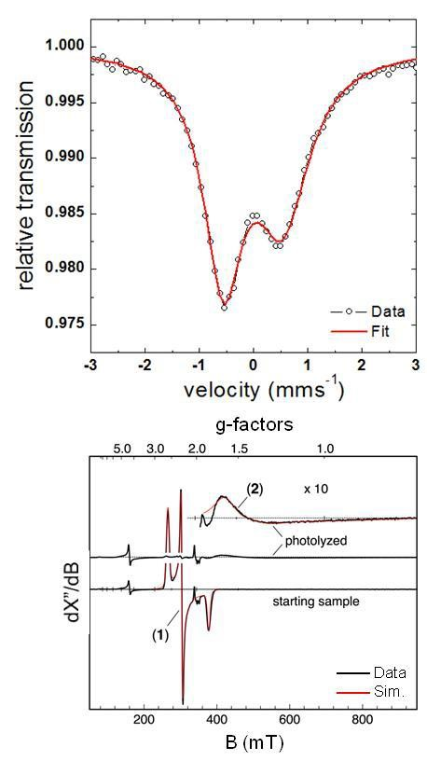4
5
6
7
8
9
10
11
12
13
14
15
16
17
18
19
20
21
22
23
24
25
26
27
28
29
30
31
32
33
34
35
36
37
38
39
40
41
42
43
44 Figure 3. (top) Zero-field Mössbauer spectrum of a 2 mM frozen solution of complex 1 enriched
45 with 57Fe after 5 h photolysis at 77 K with a 530 nm (green) LED fitted with a Lorentzian doublet
46 accounting for the high-valent photo-product 2 (~100%, red line); (bottom) EPR spectrum of a 2
47 mM frozen solution sample from the same batch in a sealed EPR tube under vacuum recorded
48 before and after photolysis (T = 10 K, frequency 9.6468 GHz, power 0.5 mW, modulation 0.75
49 mT / 100 kHz).The red line shown in the inset is a simulation for the photo-product with g values
50 g1 = 1.59, g2 = 1.33 and g3 = 0.9.
51
52
53
54
55
56
57
58
59
60

1
2
3 X-Ray Spectroscopy
4
5 The series of complexes 1, 2 and [FeII(N3)(MePy2tacn)]2+ (4) (details of its preparation
6 and characterization can be found in the supporting information) was also characterised by Fe K-
7
8 edge X-ray absorption spectroscopy (XAS), providing further insight into the electronic and
9
10 geometric structure of 1 and 2 (Table 2, Figure 4 and Figure S10). The rising edge spectra (Figure
11 4 – left) for 4, 1 and 2 are consistent with a sequential increase in the metal oxidation state.
12
13 Compound 4 with a rising edge energy of 7120.6 eV, has a small pre-edge feature attributed to
14
15 1s→3d dipole forbidden transitions at ~7111.6 eV with an intensity of ~0.045 normalized units.
16 This is consistent with a low-spin octahedral iron(II) centre having dipole forbidden pre-edge
17
18 transitions to the eg set of orbitals.43 Compound 1 on the other hand experiences a shift in its rising
19
20 edge to 7122.7 eV concomitant with a 1 eV shift in its pre-edge intensity weighted average energy.
21 The pre-edge of 1 can be fit with two low intensity peaks at 7111.9 eV and 7113.2 eV similar to
22
23 previously reported low-spin hexacoordinate iron(III) complexes. Lastly, 2 was generated by
24 irradiating a 4 mM frozen solution of 1 in acetone for 5 h at 77 K during which the colour
25
26 progressively changed from purple to orange (vide supra). Compound 2 has a rising edge at
27
28 7123.8 eV with a very intense pre-edge at 7114.2 eV and a shoulder at 7112.4 eV giving an
29 intensity weighted average pre-edge of 7113.9 eV. Such a profile correlates with the previously
30
31 reported values for the XAS spectra of the related [FeV(N)(cyclam – ac)]+ complex having a rising
32
33 edge of ~7124.1 eV and a pre-edge energy of 7113.9eV.44,45 Furthermore the pre-edge energy of
34 2 is below that of [FeVI(N)(Me3cyclam – ac)]+ (7114.4 eV) strongly pointing to the formation of
35
36 an iron(V) center.33,44,45 To obtain insight into the coordination structure of 2, EXAFS analysis
37 was carried out. A picture emerges of a six-coordinate metal center consisting of N/O scattering
38
39 atoms having a short 1.64 Å Fe-N/O bond. Presumably this corresponds to the short Fe – nitride
40
41 bond that causes a tetragonal distortion of the octahedral geometry and facilitates p-d mixing
42 through a strong metal – ligand covalent interaction resulting in a very intense pre-edge.44
43
44 Previous researchers have reported similar Fe – nitride bond lengths of 1.61 Å for the
45
46 [FeV(N)(cyclam – ac)]+ complex and 1.57 Å for [FeVI(N)(Me3cyclam – ac)]+.33,44 Comparing these
47 values to the related [FeV(N)(tBuIm3BPh)]+ complex, with an Fe – N bond of 1.502(2) Å, we have
48
49 a sensibly longer bond. This can be rationalised by the fact that 2 is a hexacoordinate complex
50 and the former is a tetradentate complex in pseudo – tetrahedral geometry, which translates to a
51

52 shorter Fe – N bond for a lower coordination number.32
53
54
55
56
57
58
59
60

1
2
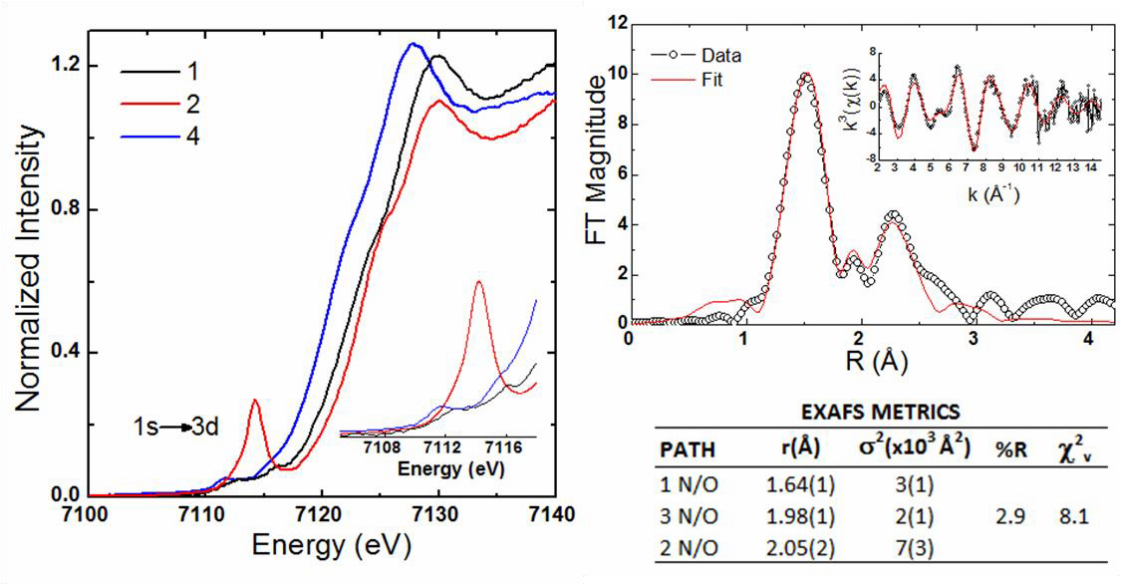3
4
5
6
7
8
9
10
11
12
13
14
15
16
17
18
19
20
21
22
23 Figure 4. (Left) Iron K – edge X – ray absorption spectra of 1 (black), 2 (red) and 4 (blue). The
24 inset is an expansion of the pre – edge region. (Right) Fourier transformed EXAFS spectra of 2
25 (inset:. k3-weighted unfiltered EXAFS spectra (Data: black circles; Fits: red line).
26
27 Table 2. Comparison of Fe – N bond distances and XAS energies.
28

29
30 Fe _ N

XAS Energies 1s→3d

31 Complex
32
33
distances
(DFT) (Å)
Eo
(eV)
Epre-edge
(eV)
Pre-edge
Intensities

34 FeII(N3)(MePy2tacn)](PF6) (2.02) 7120.6 7111.6 0.045
35 [FeIII(N3)(MePy2tacn)](PF6)2 1.86*(1.90) 7122.1 7112.7 0.054
36
37 [FeV(N)(MePy2tacn)](PF6)2 1.64 (1.60) 7123.8 7113.9 0.57
38
39 a[FeIII(N3)(cyclam – ac)]+ 1.94a 7123.0a 7112.4c 0.098c
40 a[FeV(N)(cyclam – ac)]+ 1.61 (1.60) a 7124.1a 7113.9c 0.34c
41
42 b[FeVI(N)(Me3cyclam – ac)]2+ 1.57 (1.53)b 7125.0b 7114.4c 0.44c
43 *Values from X – ray diffraction. aData from reference 44. bData from reference 33. cData from reference45
44
45
46
47 Theoretical Calculations.
48 The electronic structure of 1 and 2 was further explored with density functional theory
49
50 (see details in Supporting Information). Compound 1 was modelled as a spin 1/2 FeIII center as
51 determined from experiment. The resulting geometry optimized structure predicts a short FeIII-N
52
53 bond of 1.90 Å and an FeIIIN-N2 distance of 1.22 Å. These values correlate well with the
54
55 crystallographically determined distances of 1.86 Å and 1.25 Å, respectively. In the case of 2, a
56 low-spin S = 1/2 Fe(V) centre is found to better match experimental data having a calculated Fe
57
58 – nitride bond of 1.60 Å, matching the experimentally determined distance of 1.64 Å. A high-spin
59
60 S = 3/2 iron(V) center on the other hand is predicted to have a bond length of 1.76 Å well outside
the resolution limit of the EXAFS data (0.1 Å). Furthermore the XAS pre – edges for the series

1
2
3 were also calculated and found to correlate well to experiment (Supporting Figures S11 and S12).
4
5 Difference density maps for the transitions highlight that for 2 the intense feature at 7114.2 eV
6
7 arises from excitations to the dz2 set of orbitals which have a σ* antibonding interaction with the
8 nitride pz orbital (Supporting Figure S12). As this is a σ – type interaction p – d mixing is more
9
10 favoured (~2.7% p – character) than for transitions to π* (1.5% p – character) orbitals or
11
12 transitions to non – bonding orbitals (~0.5% p – character) the latter forming the shoulder
13 observed at 7112.4 eV.43 Therefore an orbital picture emerges for 2 consistent with a low-spin
14
15 Fe(V) centre. Using the notation Γ(X)n where Γ is the bonding nature, X is the predominant
16
17 character of the orbital, and n its occupation number,46 2 is best described as having a
18 δ(Fedxy)2π*(Fedxz,yz)1σ*(Fedx2-y2)0σ*(Fedz2)0 electronic arrangement (Figure 6). Such an
19
20 electronic arrangement matches expectations from EPR and Mössbauer data which predict a high-
21
22 valent spin 1/2 Fe center with significant orbital degeneracy as can be deduced from the drastic
23 g-shifts of 1.55, 1.33 and 0.9. Furthermore the singly occupied π* Fedxz/yz shows a strong covalent
24
25 Fe – N interaction having a ~30% Fe – character with 60% - N character similar to other highly
26
27 covalent [FeX]+n cores (X = N, O) with the Fe – N bond order best described as 2.5.44,47 Indeed,
28 the strong Fe-N π interaction destabilizes the dxz/yz orbitals relative to the dxy orbitals favouring
29
30 the (dxy)2(dxz/yz)1 configuration.44 Lastly, in 1 it is apparent that the occupied Fe 3d orbitals interact
31
32 primarily with non-bonding orbitals with respect to the N3 moiety (Figure 5). This further supports
33 the premise that the FeIIIN-N2 bond is activated by the strongly electrophilic character of the iron
34
35 center surrounded by the neutral ligand framework which stabilizes the Fe – –N–+N ≡N resonance
36
37 over the Fe – N=+N=N- resonance as previously postulated.48
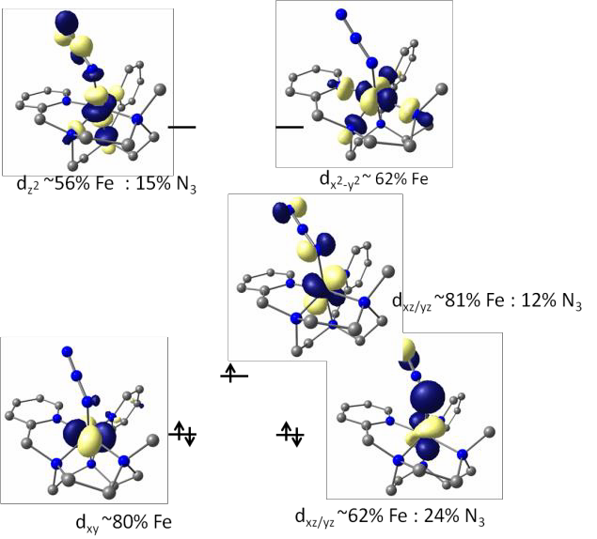38
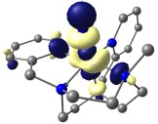39
40
41
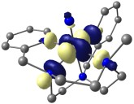42
43 dz2 ~46% Fe
44
45
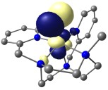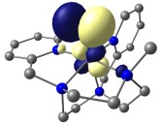46 dx2-y2 ~ 64% Fe
47
48
49
50
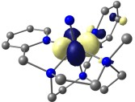51 dxz/yz ~32% Fe : 60% N dxz/yz ~41% Fe : 49% N
52
53
54
55
56 dxy ~78% Fe
57 Figure 5. Schematic molecular orbital picture highlighting the d manifold of compounds 1 (left)
58 and 2 (right), using quasi-restricted molecular orbitals at an isovalue of 0.06 (TPSSh/def2-
59 TZVP//TPSS/def2-TZVP).46
60
Analysis of the formation and decay of 2 by gas evolution.

1
2
3 A mass spectrometry online system (EI – MS) was used to analyse the gas evolution
4
5 during formation and decay of 2. First, a frozen solution of 1 – 15N was analysed during photolysis.
6 It was reasoned that this procedure should result in the production of N gas, and that the use of
2
7
8 isotopically labelled azide ligands may provide information about the mechanism (Figure 6). The
9
10 photolysis of 1 was performed on a 4 mM acetone solution (1 ml) under Ar at 77 K using a 530
11 nm LED. The solution turned from purple to orange during the irradiation process. Despite of the
12
13 change in colour, no N2 evolution could be detected while being irradiated, presumably because
14
15 the gas remains trapped inside the frozen solution. So, the analysis of the N2 formed was
16 performed by very slowly melting the sample (for 3 h) after 3.5 h of photolysis.
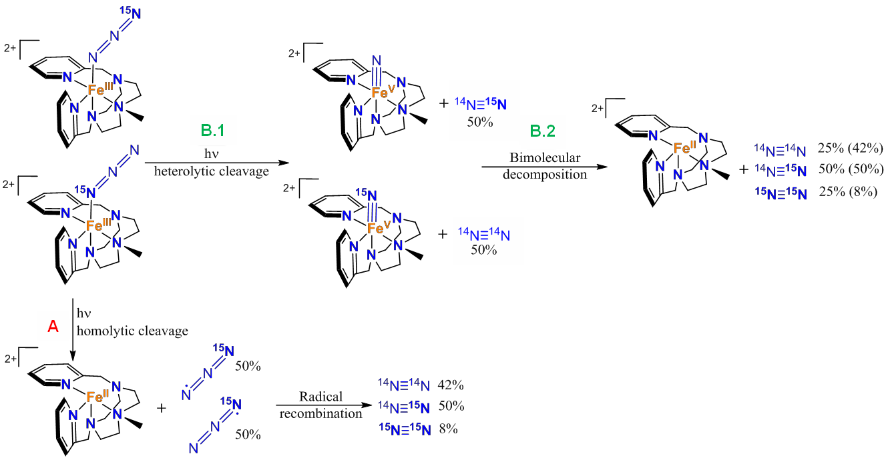17
18
19
20
21
22
23
24
25
26
27
28
29
30
31
32
33
34
35
36
37
38 Figure 6. Reactivity of 1 upon irradiation, percentages are the N2 amounts generated after
39 photolysis (percentage in parentheses are the combination of B.1 and B.2).
40
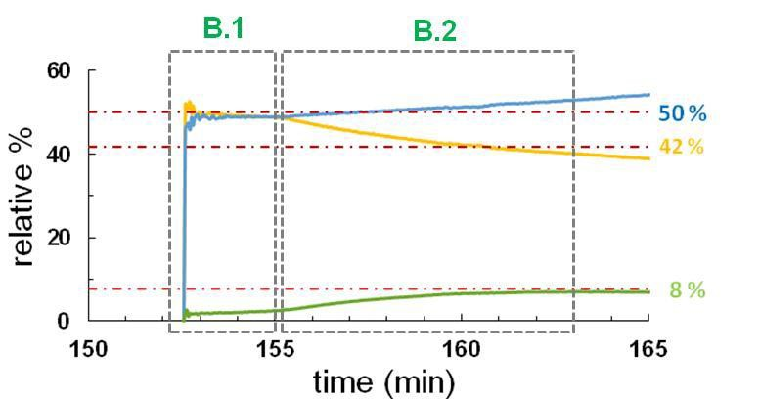41
42
43
44
45
46
47
48
49
50
51
52
53
54
55 Figure 7: Evolution of the relative composition of the nitrogen gas isotopes (14N − 14N yellow
56 line, 14N − 15N blue line and 15N − 15N green line) green line at the headspace of a solution of
57 complex 2, generated by irradiation of a solution of 1 (4 mM) in acetone at 530 nm LED for 3.5
58 hours under Ar at 77 K while slowly melting.
59
60

1
2
3 After slowly melting the sample for 2.5 h post-irradiation, N2 release was observed.
4
5 Importantly only 14N14N and 14N15N were detected, and more significantly, showing a ratio 1:1
6 which was maintained for a short period of time (ca. 5 min.). The ratio of 1:1 and the total absence
7
8 of 15N15N clearly reflects the occurrence of step B.1 (Figures 6 and 7), the photooxidation of the
9
10 iron (III) (1) to form the iron (V) species (2). Following this initial phase, that lasts for 5 minutes,
11 the 14N14N:14N15N ratio starts to differ from 1:1, in favour of the latter. Moreover, at the same time
12
13 15N15N was detected. This change suggests a bimolecular decomposition of 2 (step B.2). For a
14
15 short period of 6 - 8 minutes the proportion between 14N14N:14N15N:15N15N gases stayed close to
16 the theoretical ratio of 42:50:8 (Figure 7). This ratio is the one expected for a scenario where the
17
18 gas that emerges from the heterolytic cleavage of the N – N bond in 1 and the bimolecular
19 decomposition of 2 are combined. Of interest, Krahe, Bill, and Neese36 recently studied the
20

21 decomposition of [FeIII(N3)(cyclam-ac)]+ and [FeIII(N3)2(cyclam)]+. The study of the gases
22
23 released after photolysis and subsequently decomposition was performed by ESI – MS and
24 revealed ratios of 14N14N:14N15N:15N15N of ≈ 74:22:4 and ≈ 82:15:3, respectively. Those amounts
25
26 of 14N15N and 15N15N are lower than the expected (42:50:8), most likely due to atmospheric N2
27
28 contamination. Despite of that, the study provides clear evidence of the extrusion of 15N15N from
29 a bimolecular decay pathway contributing to N2 evolution, as the only source for the
30
31 decomposition pathway of FeV(N) species.36 The fact that, in our reaction, the ratios do not remain
32 constant over time suggests that the iron (V) species is not only decomposing through a
33

34 bimolecular pathway, but additional non-identified paths must also be occurring. This is not
35
36 surprising if we consider that 2 is expected to be a very electrophilic and reactive species, most
37 likely capable of reacting with solvent or the ligand. Alternative decomposition pathways are also
38
39 suggested by the detection of ions attributable to the CN- moiety (mass of 26 and 27), which
40
41 appear simultaneously with 15N15N gas release, presumably as 2 acquires some mobility upon the
42 melting of the frozen solution. When the blue LED photolysed sample reported in Figure 3
43
44 showing a 25% low-spin Fe(II) and 75% S = 1/2 Fe(V) content, was left to warm up to room
45 temperature under anaerobic conditions, a mixture of iron (II) and iron (III) was obtained (Figure
46
47 S13 top). Most of the final mixture (~72%) consisted of a low-spin iron(III) center (isomer shift
48
49 δ = 0.30 mm·s-1, quadrupole splitting ΔEQ = 1.41 mm·s-1). Two distinct iron (II) components were
50 also detected, the first of which was found to be in a high-spin state (21%), and the second (7%)
51

52 in a low-spin state (isomer shift δ = 1.29 and 0.57 mm·s-1, quadrupole splitting ΔEQ = 2.33 and
53
54 0.77 mm·s-1 respectively). This again suggests that the decay of 2 involves multiple paths, instead
55 of a clean decay of [FeV(N)(cyclam-ac)]+ to iron (II) upon N generation, as previously observed
2
56
57 by some of us.36
58
59 Finally, after monitoring of gases, HR – MS was performed in melted solution samples
60
(Figure S13 bottom), confirming the conclusions of the Mössbauer analysis. The decomposition

1
2
3 mixture was composed mainly of [FeIII(OH)(MePy2tacn)]2+ (m/z = 199.08) and a small amount
4
5 of unreacted 1. A small peak corresponding to the FeV species was also observed, presumably
6 resulting from the cleavage of the residual 1.
7
8
9
10
11 Gas phase reactivity
12
13 As 2 is not stable in solution its reactivity with organic molecules was studied in the gas
14
15 phase. As shown above, the nitride dication [FeV(N)(MePy2tacn)]²⁺ can be prepared by gas –
16
17 phase fragmentation of the corresponding azide dication [FeIII(N3)(MePy2tacn)]²⁺ (Figure S4 and
18 S14). The fragmentation can also be achieved during electrospray ionization by setting harder ion
19
20 – transfer conditions.38 The generated nitride [FeV(N)(MePy2tacn)]²⁺ (m/z = 197.5) was mass –
21 selected and subjected to reactions with different reagent gases.49 Firstly, reactions with dimethyl
22
23 sulfide and cis – cyclooctene were tested. As expected, the reactions proceed rapidly and the
24
25 exclusive channel is a simple addition to either the sulfur atom of dimethyl sulfide or to the
26 isolated double bond of cis – cyclooctene (Table 3, note that control experiments with the
27
28 [FeIII(N3)(MePy2tacn)]²⁺ and [FeIII(OH)(MePy2tacn)]²⁺ ions showed no comparable reactivity,
29
30 Figure S16).
31
32 Next, we explored the reactivity of the nitride with 1, 3 – and 1, 4 – cyclohexadiene
33
34 (Figure 8). The reactions are again dominated by addition of the alkene to the dication, but
35 additional minor channels are observed as well. In the case of 1, 4 – cyclohexadiene, there is also
36
37 a significant amount of the H2 transfer which most probably corresponds to the formation of
38
39 benzene. The same reaction with labelled 1, 4 – cyclohexadiene – 1, 2, 3, 4, 5, 6 – d6 leads to the
40 transfer of H2, HD, and D2 in a roughly 5:5:1 ratio. This suggests that the aromatization reaction
41
42 proceeds in two steps: one of the two has a kinetic isotope effect (KIE) of ~ 3.6, whereas the other
43 has a very small or negligible kinetic isotope effect (~ 1.4). The analysis does not permit to
44
45 establish what is the relative order of the two steps. Interestingly, the ratio between the addition
46
47 reaction and the H2 transfer products is the same irrespective of the use of unlabeled
48 cyclohexadiene or cyclohexadiene – 1, 2, 3, 4, 5, 6 – d6 as substrate (78:22). This indicates that
49
50 the step with the kinetic isotope effect is not kinetically competing with the N-transfer step.
51 Similar reactivity is observed with 1,3 – cyclohexadiene except the aromatization reaction is much
52
53 less abundant compared to the simple addition reaction.25 These results are in agreement with
54
55 previous reports from Schlangen et al. who also observed addition and H2 transfer reactions with
56 1,3 – and 1,4 – cyclohexadienes.31 In addition, Schlangen et al. observed NH2 transfer, which was
57
58 enabled by their ligand bearing amino groups in the vicinity of the nitride nitrogen (see below).
59
60 It is also interesting to compare the gas phase reactivity of 2 against cyclohexadienes with that exhibited by oxoiron(IV) complexes with tetra and pentadentate tacn based ligands.50,51

1
2
3 Reaction of the latter complexes with 1,4-cyclohexadiene entails a rate determining hydrogen
4
5 atom transfer, followed by a reaction of the cyclohexadienyl radical with a second molecule of
6 oxoiron(IV), to form benzene. In these reactions, the oxo-iron(IV) moiety acts as a single electron
7
8 oxidant. In the gas phase, all iron(IV) – oxo complexes investigated so far react with 1,4-
9
10 cyclohexadiene by hydrogen transfer as well. We could observe oxygen-transfer reactions of
11 monocationic iron(IV)-oxo complexes with 1,4-cyclohexadiene, but it stayed a minor channel (5
12
13 – 20 %). Dicationic iron(IV) – oxo complexes did not yield oxygen-transfer products; neither
14
15 addition products.49,52 In solution, oxygen atom transfer towards the olefinic site does not take
16 place, and is only observed when sulfides, which are particularly good oxygen atom acceptors,
17
18 are used as substrates. When compared with the reactivity exhibited by 2, these reactions suggest
19 an enhanced competence of the iron(V) – nitride unit to engage in two e- oxidation processes.
20
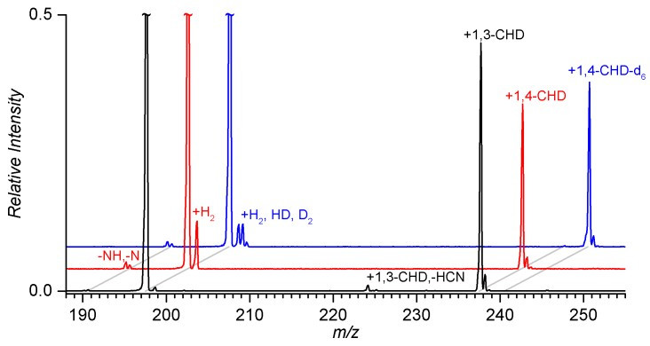21
22
23
24
25
26
27
28
29
30
31
32
33
34
35 Figure 8. Reaction of [FeV(N)(MePy2tacn)]2+ (m/z = 197.5) with ∼ 0.1 mTorr pressure of 1, 3 –
36 cyclohexadiene (black trace), 1, 4 – cyclohexadiene (red trace) and 1, 4 – cyclohexadiene-1, 2, 3,
37 4, 5, 6 – d6 (blue trace) at nominally zero collision energy. The assignments were corroborated by
38 experiments with 15N labelled nitride (Figure S17).
39
40
41
42 Table 3. Relative reaction ratesa (krel) of [FeV(N)(MePy2tacn)]2+ dication with neutral molecules.
43
44
45 Products (branching ratio)
46 Reagent gas (R) krel
47 1, 4 – cyclohexadiene 1.0 [M+R]²+ (78), [M+H₂]²⁺ (22)
48
49 1,4 – cyclohexadiene-d6 1.0 [M+R]²⁺ (78) , [M+H₂]²+ (10), [M+HD]²⁺ (10), [M+D₂]²⁺ (2)
50 1,3 – cyclohexadiene 1.1 [M+R]²⁺ (98), [M+H₂]²+ (1) [M+R-HCN]²⁺ (1)
51 cis – cyclooctene 1.5 [M+R]² + (100)
52 dimethyl sulfide 2.0 [M+R]² + (100)
53
54 a Relative to 1,4 – cyclohexadiene. Acetylene has also been tested, but no reaction was
55 observed.
56
57
58
59 On the other hand, the exact nature of the formal H2 transfer reaction cannot be
60 ascertained at present. By analogy to the chemistry exhibited by oxo-iron(IV) complexes49,51,53-55

it may be tentatively proposed to entail an initial hydrogen atom transfer, to form a

1
2
3 cyclohexadienyl radical and a [FeIV(NH)(MePy2tacn)]²⁺ species (pathway A in Scheme 2). In the
4
5 current case, the latter species are not detected and therefore this step must be followed by a
6 second and fast transfer of a hydrogen atom, to form benzene and [FeIII(NH2)(MePy2tacn)]²⁺
7

8 ([M+H2]²⁺). Alternatively, H2 elimination can proceed via the aziridine intermediate (pathway B
9
10 in Scheme 2). The low – spin nitride most probably initially adds to one of the double bonds of
11 cyclohexadienes to form the aziridine ring. In the subsequent step, a hydrogen atom from the
12
13 hydrocarbon migrates to the nitrogen atom. The second hydrogen transfer completes the reaction.
14
15 This mechanism (in agreement with the experimental results) implies that the H2 elimination from
16 1,3 – cyclohexadiene should be less abundant than for 1,4 – cyclohexadiene, because it has to be
17
18 associated with hydrogen – ring walk (unlike for 1,4 – cyclohexadiene). It also explains the
19 difference between our results and the results published previously by Schlangen et al.31 Their
20

21 ligand bears amino – groups in vicinity of the nitride nitrogen. The hydrogen transfer from the
22
23 hydrocarbon at the stage of the aziridine intermediate is thus in competition with the hydrogen
24 transfer from the ligand. We can see this process as well, but in very low abundance as trace NH
25
26 elimination (see Figure 8). Furthermore, mechanism B can probably better account for the lack
27
28 of an effect from deuteration on the ratio between the addition and H2 transfer products.
29 Nevertheless, validation of the elemental steps of this reaction will require extensive
30
31 computational analysis, but the complexity of the problem, requiring the calculation of the
32 different mechanisms for multiple spin states makes this task beyond the objectives of this work.52
33
34
35
36
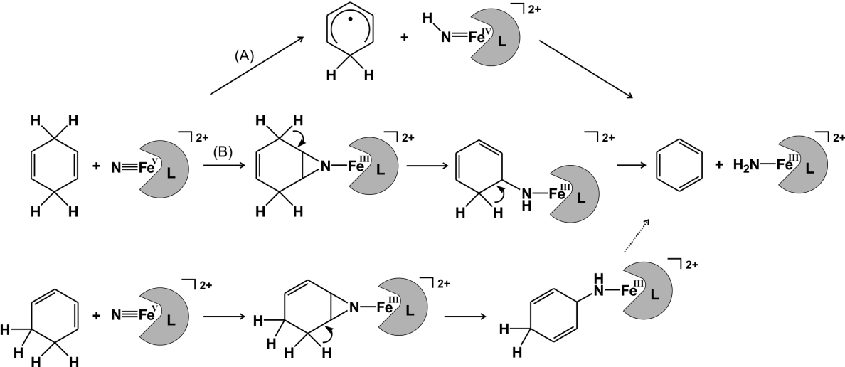37
38
39
40
41
42
43
44
45
46
47
48
49
50
51
52
53
54 Scheme 2. Possible pathways in reaction of iron(V) – nitride with 1,3- and 1,4-cyclohexadiene.
55
56
57
58
59
60

1
2
3 Conclusions
4
5 Octahedral iron – azide complex 1 bearing a neutral pentadentate aminopyridine ligand based on
6
7 the macrocycle triazacyclononane framework has been synthesised and studied as a potential
8
9 precursor of high-valent iron – nitride species. Photolysis of 1 results in photooxidative cleavage
10 of the N – N bond on the azide moiety, extruding N2 to generate the high – valent iron (V) –
11
12 nitride species 2 in the gas phase and also upon photolysis in frozen solution or as a powder at 77
13
14 K. Analysis of the N2 gas mixtures generated upon photolysis of 1 by MS - online techniques give
15 further evidence of an heterolytic N2 extrusion. Iron(V) nitride species 2, generated by photolysis
16
17 of 1 was studied in detail by Mössbauer spectroscopy, EPR, SQUID and XAS, and identified as
18 a low-spin (S = 1/2) iron(V) – nitrido species. XAS analysis confirmed the existence of a very
19
20 short Fe – N bond in high concordance with previously reported high – valent iron (V) species.
21
22 These species are highly reactive and rapidly decompose upon warming, so its reactivity in
23 solution could not be investigated. MS – online techniques provide evidence that decomposition
24
25 of 2 involves N – N bond formation. Reactivity of 2 in the gas phase indicates that the complex
26
27 adds to olefinic sites. Reactions with cyclohexadienes also result in a formal H2 transfer from the
28 substrate to the FeV(N) center, forming FeIII(NH2) species and aromatization of the substrate.
29
30 Compound 2 can also react with sulphides via a nucleophilic attack to the nitride moiety. Overall,
31 the reactivity of the iron(V) – nitride species in the gas phase indicates that it is a competent 2e-
32
33 oxidant, showing reactivity not attained by iron(IV) species. In a more general context, the
34
35 structural and chemical versatility of the aminopyridine ligand scaffold employed in this work is
36 envisioned as a promising tool for further development of the chemistry of Fe(V) species.
37
38
39
40
41 Supporting Information
42
43 CIF file of complex 1. Experimental details on the preparation of 1 and 3, and of the generation of 2.
44 Spectroscopic data for the spectroscopic characterization of 1 and 2. Spectroscopic and magnetic
45
46 susceptibility data corresponding to the characterization of solid samples of 2. UV-Vis spectra of the
47 photolysis of 1 in solution. Spectra corresponding to gas phase reactivity of 2. XYZ files of geometry
48
49 optimized structures.
50
51
52
53 Acknowledgements
54 We acknowledge financial support from European Research Council (ERC-2009-StG-239910 to MC and
55
56 ERC CoG No. 682275 to JR), MINECO of Spain and Fondo Europeo de Desarrollo Regional (CTQ2015-
57 70795-P/BQU), and the Catalan DIUE of the Generalitat de Catalunya (2009SGR637). M.C. thank ICREA-
58
59 Academia award. The project was supported by the Czech Science Foundation (14-20077S), and the COST
60 action ECOSTBio. We thank Diamond Light Source for access to beamline B18 (proposal SP13863-1) that contributed to the results presented here. Also, we would like to thank SOLEIL for access to the SAMBA

1
2
3 beamline (proposal 20151019) as well as Dr. Landrot Gautier for his help with experimental setup.
4
5
6
7
8
9
10
11
12
13
14
15
16
17
18
19
20
21
22
23
24
25
26
27
28
29
30
31
32
33
34
35
36
37
38
39
40
41
42
43
44
45
46
47
48
49
50
51
52
53
54
55
56
57
58
59
60

1
2
3 References
4
5
6 (1) McDonald, A. R.; Que Jr., L. Coord. Chem. Rev. 2013, 257, 414.
7 (2) Groves, J. T. J. Inorg. Biochem. 2006, 100, 434.
8 (3) Costas, M.; Mehn, M. P.; Jensen, M. P.; Que Jr., L Chem. Rev. 2004, 104, 939.
9
10 (4) Hohenberger, J.; Ray, K.; Meyer, K. Nat Commun 2012, 3, 720.
11 (5) Wallar, B. J.; Lipscomb, J. D. Chem. Rev. 1996, 96, 2625.
12 (6) Nam, W.; Lee, Y.-M.; Fukuzumi, S. Acc. Chem. Res. 2014, 47, 1146.
13 (7) Sahu, S.; Goldberg, D. P. J. Am. Chem. Soc. 2016, 138, 11410.
14 (8) Rittle, J.; Green, M. T. Science 2010, 330, 933.
15 (9) Krebs, C.; Galonic ́ Fujimori, D.; Walsh, C. T.; Bollinger, J. M. Acc. Chem. Res.
16
17 2007, 40, 484.
18 (10) Banerjee, R.; Proshlyakov, Y.; Lipscomb, J. D.; Proshlyakov, D. A. Nature 2015,
19 518, 431.
20 (11) Zandi, O.; Hamann, T. W. Nat Chem 2016, 8, 778.
21 (12) Codola, Z.; Gomez, L.; Kleespies, S. T.; Que, L., Jr.; Costas, M.; Lloret-Fillol, J.
22 Nat Commun 2015, 6.
23 (13) Panda, C.; Debgupta, J.; Diaz Diaz, D.; Singh, K. K.; Gupta, S. S.; Dhar, B. B. J.
24
25 Am. Chem. Soc. 2014, 136, 12273.
26 (14) Hoffman, B. M.; Lukoyanov, D.; Yang, Z.-Y.; Dean, D. R.; Seefeldt, L. C. Chem.
27 Rev. 2014, 114, 4041.
28 (15) Mehn, M. P.; Peters, J. C. J. Inorg. Biochem. 2006, 100, 634.
29 (16) Smith, J. M.; Subedi, D. Dalton Trans. 2012, 41, 1423.
30 (17) Berry, J. F. Comm. Inorg. Chem. 2009, 30, 28.
31
32 (18) Smith, J. M. In Prog. Inorg. Chem., Vol 58; Karlin, K. D., Ed.; John Wiley & Sons
33 Inc: Hoboken, 2014; Vol. 58, p 417.
34 (19) Wagner, W. D.; Nakamoto, K. J. Am. Chem. Soc. 1989, 111, 1590.
35 (20) Hendrich, M. P.; Gunderson, W.; Behan, R. K.; Green, M. T.; Mehn, M. P.;
36 Betley, T. A.; Lu, C. C.; Peters, J. C. Proc. Nat. Acad. Sci. 2006, 103, 17107.
37 (21) Betley, T. A.; Peters, J. C. J. Am. Chem. Soc. 2004, 126, 6252.
38 (22) Vogel, C.; Heinemann, F. W.; Sutter, J.; Anthon, C.; Meyer, K. Angew. Chem. Int.
39
40 Ed. 2008, 47, 2681.
41 (23) Scepaniak, J. J.; Fulton, M. D.; Bontchev, R. P.; Duesler, E. N.; Kirk, M. L.; Smith,
42 J. M. J. Am. Chem. Soc. 2008, 130, 10515.
43 (24) Scepaniak, J. J.; Bontchev, R. P.; Johnson, D. L.; Smith, J. M. Angew. Chem. Int.
44 Ed. 2011, 50, 6630.
45 (25) Lee, W.-T.; Juarez, R. A.; Scepaniak, J. J.; Muñoz, S. B.; Dickie, D. A.; Wang, H.;
46 Smith, J. M. Inorg. Chem. 2014, 53, 8425.
47
48 (26) Muñoz, S. B.; Lee, W.-T.; Dickie, D. A.; Scepaniak, J. J.; Subedi, D.; Pink, M.;
49 Johnson, M. D.; Smith, J. M. Angew. Chem. Int. Ed. 2015, 54, 10600.
50 (27) Scepaniak, J. J.; Margarit, C. G.; Harvey, J. N.; Smith, J. M. Inorg. Chem. 2011,
51 50, 9508.
52 (28) Scepaniak, J. J.; Young, J. A.; Bontchev, R. P.; Smith, J. M. Angew. Chem. Int. Ed.
53 2009, 48, 3158.
54
55 (29) Grapperhaus, C. A.; Mienert, B.; Bill, E.; Weyhermüller, T.; Wieghardt, K. Inorg.
56 Chem. 2000, 39, 5306.
57 (30) Meyer, K.; Bill, E.; Mienert, B.; Weyhermüller, T.; Wieghardt, K. J. Am. Chem.
58 Soc. 1999, 121, 4859.
59 (31) Schlangen, M.; Neugebauer, J.; Reiher, M.; Schröder, D.; López, J. P.; Haryono,
60 M.; Heinemann, F. W.; Grohmann, A.; Schwarz, H. J. Am. Chem. Soc. 2008, 130, 4285.

1
2
3 (32) Scepaniak, J. J.; Vogel, C. S.; Khusniyarov, M. M.; Heinemann, F. W.; Meyer, K.;
4 Smith, J. M. Science 2011, 331, 1049.
5
6 (33) Berry, J. F.; Bill, E.; Bothe, E.; George, S. D.; Mienert, B.; Neese, F.; Wieghardt,
7 K. Science 2006, 312, 1937.
8 (34) Song, Y.-F.; Berry, J. F.; Bill, E.; Bothe, E.; Weyhermüller, T.; Wieghardt, K. Inorg.
9 Chem. 2007, 46, 2208.
10 (35) Cutsail Iii, G. E.; Stein, B. W.; Subedi, D.; Smith, J. M.; Kirk, M. L.; Hoffman, B. M.
11 J. Am. Chem. Soc. 2014, 136, 12323.
12 (36) Krahe, O.; Bill, E.; Neese, F. Angew. Chem. Int. Ed. 2014, 53, 8727.
13
14 (37) Torres-Alacan, J.; Das, U.; Filippou, A. C.; Vöhringer, P. Angew. Chem. Int. Ed.
15 2013, 52, 12833.
16 (38) Schröder, D.; Schwarz, H.; Aliaga-Alcalde, N.; Neese, F. Eur. J. Inorg. Chem.
17 2007, 2007, 816.
18 (39) Nakamoto, K. Infrared and Raman Spectra of Inorganic and Coordination
19 Compounds. Part B: Application in Coordination, Organometallic, and Bioinorganic Chemistry,
20
21 5th Edition; John Wiley & Sons, Inc.: Hoboken, New Jersey, 2009.
22 (40) Company, A.; Sabenya, G.; Gonzalez-Bejar, M.; Gomez, L.; Clemancey, M.;
23 Blondin, G.; Jasniewski, A. J.; Puri, M.; Browne, W. R.; Latour, J. M.; Que Jr., L. ; Costas, M.;
24 Perez-Prieto, J.; Lloret-Fillol, J. J. Am. Chem. Soc. 2014, 136, 4624.
25 (41) Aasa, R. V., T. J. Mag. Res. 1975, 19, 308.
26 (42) Krahe, O. M., Rheinischen Friedrich-Wilhelms-Universität Bonn, 2016.
27 (43) Westre, T. E.; Kennepohl, P.; DeWitt, J. G.; Hedman, B.; Hodgson, K. O.;
28
29 Solomon, E. I. J. Am. Chem. Soc. 1997, 119, 6297.
30 (44) Aliaga-Alcalde, N.; DeBeer George, S.; Mienert, B.; Bill, E.; Wieghardt, K.;
31 Neese, F. Angew. Chem. Int. Ed. 2005, 44, 2908.
32 (45) Chandrasekaran, P.; Stieber, S. C. E.; Collins, T. J.; Que Jr. L. ; Neese, F.; DeBeer,
33 S. Dalton Trans. 2011, 40, 11070.
34 (46) Ye, S.; Geng, C.-Y.; Shaik, S.; Neese, F. Phys. Chem. Chem. Phys. 2013, 15, 8017.
35 (47) Berry, J. F.; DeBeer George, S.; Neese, F. Chem. Chem. Phys. 2008, 10, 4361.
36
37 (48) Dori, Z.; Ziolo, R. F. Chem. Rev. 1973, 73, 247.
38 (49) Andris, E.; Jasik, J.; Gomez, L.; Costas, M.; Roithova, J. Angew. Chem. Int. Ed.
39 2016, 55, 3637.
40 (50) Company, A.; Prat, I.; Frisch, J. R.; Ballesté, R. M.; Güell, M.; Juhász, G.; Ribas,
41 X.; Münck, E.; Luis, J. M.; Que Jr., L.; Costas, M. Chem. Eur. J. 2011, 17, 1622.
42 (51) Wang, D.; Ray, K.; Collins, M. J.; Farquhar, E. R.; Frisch, J. R.; Gomez, L.; Jackson,
43
44 T. A.; Kerscher, M.; Waleska, A.; Comba, P.; Costas, M.; Que Jr., L. Chem. Sci. 2013, 4, 282.
45 (52) Andris, E.; Navrátil, R.; Jašík, J.; Terencio, T.; Srnec, M.; Costas, M.; Roithová, J.
46 J. Am. Chem. Soc. 2017, 139, 2757.
47 (53) Cho, K.-B.; Hirao, H.; Shaik, S.; Nam, W. Chem. Soc. Rev. 2016, 45, 1197.
48 (54) Cho, K.-B.; Wu, X.; Lee, Y.-M.; Kwon, Y. H.; Shaik, S.; Nam, W. J. Am. Chem. Soc.
49 2012, 134, 20222.
50 (55) Kaizer, J.; Klinker, E. J.; Oh, N. Y.; Rohde, J.-U.; Song, W. J.; Stubna, A.; Kim, J.;
51
52 Munck, E.; Nam, W.; Que Jr., L. J. Am. Chem. Soc. 2004, 126, 472.
53
54
55
56
57
58
59
60

1
2
3 TOC
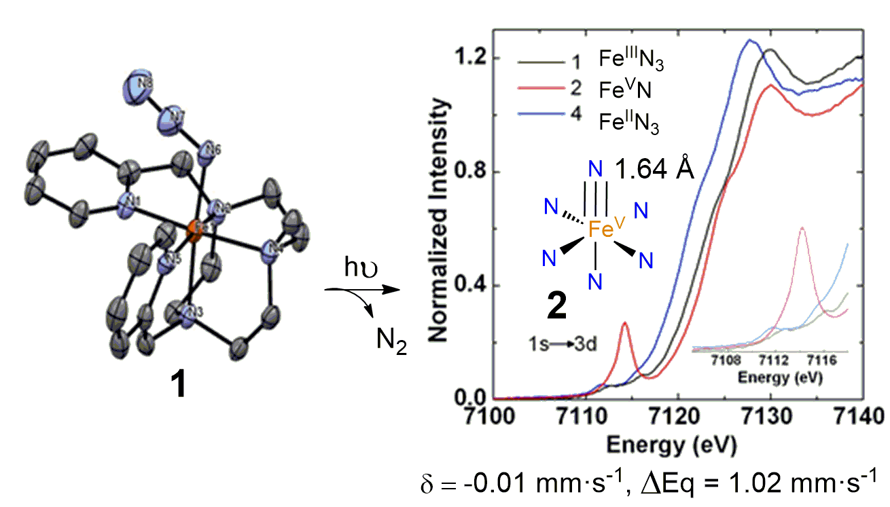4
5
6
7
8
9
10
11
12
13
14
15
16
17
18
19
20
21
22
23
24
25
26
27
28
29
30
31
32
33
34
35
36
37
38
39
40
41
42
43
44
45
46
47
48
49
50
51
52
53
54
55
56
57
58
59
60

